Subject: ENGLISH 2  Lesson plan: 1  Date of teaching: 22/02/2016 | Time allowed: 7 periods | Total period taught: 0

UNIT 1: What can you do there?
I. OBJECTIVES: By the end of the lesson, the students will be able to:
-Listen to people talking about things to do in their cities
-Talk about cities
-Read an article about Rome
-Enhance target vocabulary items about tourist attractions
-Learn can and can’t
-Practise pronouncing can and can’t
II. METHOD
Integrated, communicative oriented teaching approach.
III. TECHNIQUES
-Pair work.
-Group work.
IV. TEACHING AIDS
Textbook.
Black board, chalk.
Pictures for teaching vocabulary.
Cassette player, amplifier, microphone.
V. PROCEDURE
A. Greetings.
B. Checking students’ attendance: 5 minutes
C. Warm-up.
D.New lesson.

Lesson’s Contents | Time | Teacher’s activities | Students’ activities
1.Vocabulary: The goal of this section is to present the target vocabulary of the unit  1.1.Activity 1:  Warm-up  1.2. Activity 2:  Picture labelling  1.3. Activity 2:  Pair work:  1.3. Activity 3:  Listen and check  1.4. Activity 3:  Stretch your vocabulary  2. Conversation: The goal of this section is to talk about places to visit  2.1. Activity 1:  Picture describing.  2.2. Activity 2:  Listen and check  2.3. Activity 3:  Pair work  2.4. Activity 4:  Free production  3. Language Practice: The goal of this section is to present and practice the target grammar: can and can’t  3.1. Activity 1:  Complete the questions.  3.2. Activity 2:  Complete the conversations  3.3. Activity 3:  Pair work  4. Pronunciation: The goal of this section is to present the way to reduce “can” and “can’t”.  4.1. Activity 1:  Listen and repeat.  4.2. Activity 2:  Pair work – Free production  5. Listening: The goal of this section is to present and practice listening for specific information and to do the listening exercises.  5.1. Activity 1:  Picture describing  Activity 2:  Listen and number the pictures  Activity 2:  Listen and write the correct letter  6. Smart Talk: The goal of this section is to practice speaking for specific topic: Don’t miss it!  6.1. Activity 1:  Fill-in-the-blank and pair-work activities (Controlled practice)  6.2. Activity 2:  Fill-in-the-blank and pair-work activities(Open practice)  7. Reading: The goal of this section is to practice reading comprehesion.  7.1. Activity 1:  Picture describing  7.2. Activity 2:  Reading comprehesion  8. Enjoying English: The goal of this section is to practice language in the unit in an enjoyable, meaningful and personalized way.  8.1. Activity 1:  Picture describing  8.2. Activity 2:  Pair work  8.3. Activity 3:  Group work  9. Writing: The goal of this section is to present and practice writing for a specific topic.  9.1. Activity 1:  Write a paragraph  9.2. Activity 2:  Pair work | 25’  20’  45’  15’  40’  40’  60’  40’  45’ | -T elicits the names of famous places in Vietnam that Ss already know.  - T focuses Ss’ attention on the pictures.  -T checks which places students already know.  -T models the target vocabulary.    Changdeok Palace: using picture    Tokyo Disneyland:using picture    The Statue of Christ: using picture  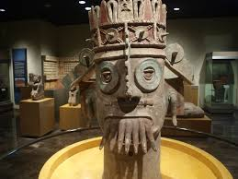  The Museum of Anthropology:using picture  -T asks Ss to complete the activity on their own  - T models the conversation  -T has Ss work in pair and do the activity.  - T lets Ss work in pairs practicing speaking. (T corrects the pronunciation mistakes if any.)  -T plays the CD player.  -T allows time for Ss to change incorrect answers.  - T asks Ss to make a list of other local attractions they know.  - T has Ss look at the picture and asks them some questions.  What can you see in the pictures?  Where are they?  Have you ever come to those places?  Have you ever seen those places on TV?  Do you want to visit those places?  - T focuses students’ attention on the model conversation and explains how it relates to the pictures in activity 1.  - T pre-teaches some words:  easy:  cool things  subway  - T has Ss complete the conversation on their own.  - T lets Ss listen to the conversation and check their answers.  - T has Ss work in pairs practicing the conversation.  - T checks pronunciation and intonation.  - T has Ss practice the conversation in pairs again substituting the blanks with the new words given.  - T has students practice the conversation in pairs using their own ideas.  -T asks Ss to observe the examples in the book.  -T elicits the meaning of the examples.  -T elicits the use of can/ can’t  -T has Ss give examples to check understandings  - T asks Ss to complete the questions in pairs.  - T sets time-limit.  - T conducts the feedback orally.  - T asks Ss to complete the conversations in pairs.  - T sets time-limit.  - T conducts the feedback orally.  - T elicits some means of transportation and related phrases.  -T models the example and gives instructions.  - T lets Ss answer the questions in pairs.  - T sets time-limit.  - T conducts the feedback orally.  - T models examples.  - T asks students to say what they notice.  - T has Ss listen and repeat the sentences.  - T asks Ss to work in pairs practicing the conversation in Activity 2  - T focuses Ss’ attention on the pictures and asks them some questions.  What do you know about those places?  What can you do there?  -T reviews some vocabulary.  -T asks Ss to guess the meaning of conversation.  -T asks Ss to pay attention on the key words.  - T plays the CD and lets Ss listen and number the pictures.  - T checks the answers orally.  - T gives instruction.  - T plays the CD and lets Ss listen and write the correct letter.  - T checks the answers orally.  - T pre-teaches some new words  New year’s eve:explaining the meaning    firework display: using picture  vote for :explaining the meaning  famous(adj) using example  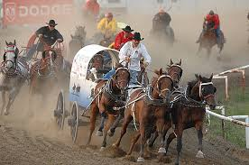  chuckwagon race: using picture  - T assigns roles and gives instructions.  - T asks Ss to work in pairs asking and answering the questions to do the gap-filling.  - T asks Ss to work in pairs to ask and answer comprehension questions  - T focuses Ss’ attention on the pictures and asks them some questions:  Do you know any of these places?  Do you know Rome?  What do you know about Rome?  - T teaches new words if necessary.  Capital(n): giving examples  Coast(n): using picture    Mild (adj):using semantic map history(n):explaining meaning.  Ruin (n):giving meaning  Ancient(adj):using antonym  Sensational(adj):using synonym  - T asks Ss to read the text silently  -T plays the recording.  -T has Ss do the activity in pairs.  - T checks students’ answers.  - T focuses Ss’ attention on the pictures and asks them some questions:  Do you know New Zealand  What can you do in New Zealand?  - T elicits related vocabulary  -T models the example conversation.  -T lets Ss go around, asking and answering the questions  - T lets Ss work and group and share their information .  - T asks Ss to read the article and answer some comprehension questions.  Where is the place?  What is interesting there?  What can you do there?  - T asks Ss to write a paragraph about their town/ city taking the comprehension questions as clues.  - T asks Ss to speak up, exchange information and compare paragraphs with their partners. | -Ss respond to T.  -Ss look at pictures.  -Ss take note new words.  -Ss do the activity.  -Ss listen to T.  -Ss work in pair and practice saying the conversation.  -Ss check the answers.  Answer:  1h – 2b – 3e – 4a – 5d – 6g – 7f – 8c  -Ss look at the picture and answer the questions.  -Ss focus on the model conversation.  -Ss take note new words and phrases.  -Ss do the activity and check the answers.  Answer:  1b – 2c – 3a – 4d  -Ss practice saying conversation in pairs.  -Ss do the activity.  -Ss practice conversation.  -Ss observe the examples.  -Ss tell T the use of can and can’t  -Ss give their own examples.  -Ss do the activity and check the answers.  Answer:  1.can, watch  2can, take  3.can, buy  4.can, eat  5.can, meet  -Ss complete the task.  -Ss check the answers.  Answer:  1.can I look at, can go, can I get, can get  2.can I go, can go, can I do, can  3.can I, can go, can I get, you can  -Ss respond to T.  -Ss answer the questions in pairs.  Answer:  go by car/ bus/ train/ taxi/ bike…  go on foot/ walk  take a train/ taxi/ bus/ subway…  - Ss listen and notice the pronunciation of can and can’t.  -Ss repeat after T.  -Ss work in pairs and do the activity.  -Ss focus on pictures and answer the questions.  -Ss take note new vocabulary.  -Ss guess the content.  -Ss focus on the questions and key words.  -Ss listen and number the pictures.  -Ss check the answer.  Answer:  New York: 2  Rio de Janeiro: 1  Paris: 3  -Ss listen to T.  -Ss do the activity and check the answers.  Answer: 1b – 2c – 3a  -Ss take note new words and phrases.  -Ss follow the instruction.  -Ss do the activity in pairs.  -Ss do the activity in pairs.  -Ss look at pictures and answer questions.  -Ss listen and take note new words.  -Ss read the text.  -Ss listen and answer the questions.  Answer:  1.About 20 kilometers  2Mild and sunny  3.Sensational  4.Quite small  5.On foot  -Ss focus on the pictures and answer questions.  -Ss follow the T.  -Ss do the activity.  -Ss work in group and do the activity.  -Ss read the sample paragraph and answer questions.  -Ss write a paragraph on their own.  -Ss exchange their work.

VI. SUMMARY OF UNIT 1:
- T reminds Ss about:
+ Can and can’t
+ Vocabulary and Grammar Exercise.
VII. HOMEWORK:
- Ss have to do again all the exercises.
- Ss prepare for the new lesson.
VIII. SELF-ASSESSMENT:
- The teaching methods are good because:
+ There are facilities and materials for students to study better.
+ The teacher’s preparation is careful.
10th, February, 2016
ADOPTION OF ENGLISH GROUP Teacher’s signature

PHẠM THỊ THU HIỀN

Subject: ENGLISH 2  Lesson plan: 2  Date of teaching: 14/03/2016 | Time allowed: 7 periods | Total period taught: 7
UNIT 2: IS THERE A BANK NEAR HERE?
I. OBJECTIVES: By the end of the lesson, the students will be able to:
-Listen to tourist asking for information.
-Talk about places.
-Read an article about a famouse mall in America.
-Enhance target vocabulary about places.
-Learn there is and there are
-Practise linked sounds.
II. METHOD
Integrated, communicative oriented teaching approach.
III. TECHNIQUES
-Pair work.
-Group work.
IV. TEACHING AIDS
Textbook.
Black board, chalk.
Pictures for teaching vocabulary.
Cassette player, amplifier, microphone.
V. PROCEDURE
A. Greetings.
B. Checking students’ attendance: 5 minutes
C. Revision of the old lesson

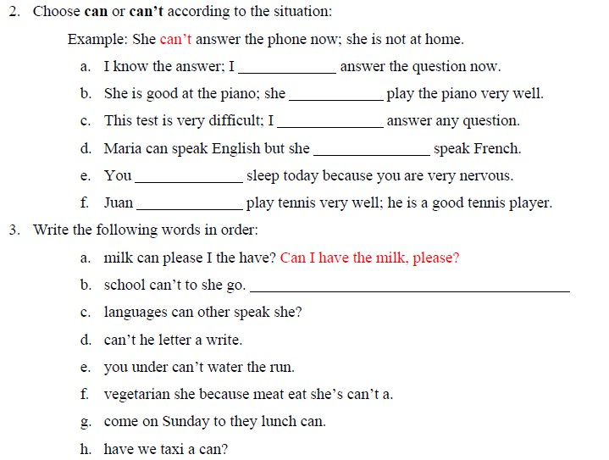

D.New lesson.

Lesson’s contents | Time | Teacher’s activities | Students’ activities
1. Vocabulary: The goal of this section is to present the target vocabulary of the unit  1.1. Activity 1:  Picture labelling  1.2. Activity 2:  Listen and check  1.3. Activity 3:  Pair work  2. Conversation: The goal of this section is to talk about places to visit  2.1. Activity 1:  Picture describing  2.2. Activity 2:  Listen and check  2.3. Activity 3:  Pair work  2.4. Activity 4:  Free practice  3. Language Practice: The goal of this section is to present and practice the target grammar: there is and there are  3.1. Activity 1:  Complete the sentences.  3.2. Activity 2:  Complete the questions  3.3. Activity 3:  Pair-work  4. Pronunciation: The goal of this section is to present the way to pronounce linked consonant and vowel sounds  4.1. Activity 1:  Listen and repeat  4.2. Activity 2:  Pair work  5. Listening: The goal of this section is to practice listening selectively for key information.  5.1. Activity 1:  Picture describing  5.2. Activity 2:  Listen and number  5.3. Activity 2:  Listen and match  6. Smart Talk: The goal of this section is to practice speaking for specific topic: Is there a bank?  6.1. Activity 1:  Fill-in-the-blank and pair-work activities (Controlled practice)  6.2. Activity 2:  Fill-in-the-blank and pair-work activities(Open practice)  7. Reading: The goal of this section is to practice reading comprehesion.  7.1. Activity 1:  Picture describing  7.2. Activity 2:  Read and match phrase with its meaning  7.3. Activity 3  Answer the question  8. Enjoying English: The goal of this section is to practice language in the unit in an enjoyable, meaningful and personalized way.  8.1. Activity 1:  Pair work  8.2. Activity 2:  Group work  9. Writing: The goal of this section is to present and practice writing for a specific topic.  9.1. Activity 1:  Write a paragraph about the street where you live  9.2. Activity 2:  Pair work  speak up and exchange information about their emails. | 25’  20’  45’  15’  40’  25’  60’  25’  45’ | - T focuses Ss’ attention on the pictures.  - T checks which places Ss already know.  - T models the target vocabulary, using pictures.    Convenience store  Department store      Music store    Bank  - T plays the CD player.  -T asks Ss to complete the activity on their own.  -T checks the answers.  Students listen and check their work in Activity 1.  -T gives instruction.  -T has Ss do the activity in pairs.  - T lets Ss work in pairs practicing speaking.  -T has a few pairs present their conversations to the class.  -T corrects the pronunciation mistakes if any.  - T has Ss look at the picture and asks them some questions.  Where are they?  Who are they?  What are they talking about?  What does the man want?  - T focuses Ss’ attention on the conversation and explains how it relates to the pictures in activity .1  -T pre-teaches some words:  Change: using explanation.  Neighborhood:using semantic map.  Downtown: giving examples.  across the street:using mime  - T has Ss complete the conversation on their own.  - T lets Ss listen to the conversation and check their answers.  - T has Ss work in pairs practicing the conversation.  - T has Ss practice the conversation in pairs again substituting the blanks with the new words given in the box.  -T does an example.  - T has Ss practice the conversation in pairs using their own ideas.  - T presents the examples and asks Ss to observe them.  -T elicits the meaning of examples.  - T introduces the structures of there is and there are.  -T asks Ss to give more examples to check understanding.  - T asks Ss to complete the sentences in pairs.  - T sets time-limit.  - T conducts the feedback orally.  -T gives instruction.  - T asks Ss to complete the questions in pairs.  - T sets time-limit.  - T conducts the feedback orally.  - T elicits some prepositions and related phrases.  Across the street, around the corner, etc.  - T gives instructions and lets Ss answer the questions in pairs.  - T sets time-limit.  - T conducts the feedback orally.  -T models the examples first.  - T plays the CD player and asks Ss to listen the pronunciation of linked consonant and vowel sounds  - T has Ss listen and repeat the sentences.  - T asks Ss to work in pairs practicing asking and answering questions about themselves.  - T focuses Ss’ attention on the pictures and asks them some questions.  Who are they?  Where are they?  Where do you think the man want to go?  -T asks Ss to guess the content of the conversations.  -T gives Ss instruction and asks Ss to focus on the key words  - T plays the CD player and lets Ss listen and number the places.  - T checks the answers orally.  - T plays the CD player and lets Ss listen and match the places with the locations.  - T checks the answers orally.  - T reviews some prepositions of place  - T assigns roles and gives instructions  - T asks Ss to work in pairs asking and answering the questions to complete the map.  - T writes the model conversation on the board  - T asks Ss to work in pairs to ask and answer the questions and complete the sentences  - T focuses Ss’ attention on the pictures and asks them some questions:  Where is it?  What is special about this shopping mall?  - T teaches new words if necessary.  entertainment place:using examples  retail are: using explanation    indoor amusement park:using picture  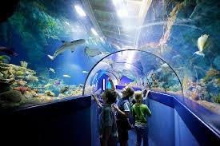  aquarium:using picture  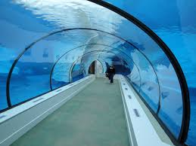  underwater tunnel:using picture  - T asks Ss to read the text silently and do the activity in pairs.  -T checks the answers.  - T asks Ss to read the text silently and answer the question in pairs.  - T checks the answers.  - T focuses Ss’ attention on the question:  What are your favorite places …?  -T elicits some examples from Ss.  - T lets Ss work in pair and do the activity.  - T models how to extend the conversation by using questions with How, Why, Where, etc.  - T lets Ss work in group and share their information  - T asks Ss to read the letter  - T asks Ss to write a paragraph about their town/ city.  - T asks Ss to speak up, exchange information and make the list of similarities and differences. | -Ss focus on the pictures.  -Ss respond to T.  -Ss take note the new words.  -Ss listen and do the activity.  -Ss check the answers.  Answer:  1j – 2e – 3f – 4h – 5b – 6c – 7g – 8a – 9i – 10d  -Ss follow T’s instruction.  -Ss do matching task.  -Ss practice saying conversation in pairs.  -Ss present in front of class.  Answer:  1g – 2e – 3a – 4b – 5c – 6d – 7f  -Ss focus on the picture and respond to T.  -Ss read the model conversation.  -Ss take note new words.  -Ss listen and check the answer.  Answer:  1d – 2c – 3b – 4a  -Ss practice conversation in pairs.  -Ss do the activity.  -Ss listen to T and do the activity.  -Ss observe the examples in book.  -Ss respond to T.  -Ss do the activity.  -Ss check the answer.  Answer:  1There’s  2.There isn’t, there’s  3.There isn’t  4.There aren’t  5.There’s, there aren’t  6.There aren’t, there are  -Ss do the activity.  -Ss check the answer.  Answer:  1.Is there  2Is there  3.Are there  4.Are there  5Are there  6.Is there  -Ss respond to T and take note new phrases.  -Ss do the activity in pairs.  -Ss listen and repeat.  -Ss practice saying examples.  -Ss work in pair and do the activity.  -Ss look at picture and answer questions.  -Ss guess the content of conversations.  -Ss listen to T.  -Ss listen and do the activity.  -Ss check the answer.  Answer:  1.swimming pool  2.park  3.shoe stores  4.coffee shop  -Ss listen and do the listening task.  -Ss check the answer.  Answer:  1d – 2a – 3b – 4c  -Ss take note new words.  -Ss follow the instruction.  -Ss do the activity in pairs.  -Ss listen to T.  -Ss make pairs and do the activity.  -Ss focus on the pictures and answer the questions.  -Ss take note new words.  -Ss do the activity in pairs.  -Ss check the answers.  Answer:  1c – 2a – 3d – 4b  -Ss do the activity.  -Ss check the answer.  Answer:  1.Seven nightclubs, an inside amusement park, an aquarium, and Camp Snoopy  2.Walt Disney World and the Grand Canyon  3.About 13000 people work there in the summer  4.Visitors from the UK, Japan, and Europe go there  5.In the underground tunnel  -Ss answer the question.  -Ss make pairs and do the activity.  -Ss listen to T.  -Ss do the activty in group.  -Ss read the sample letter.  -Ss write their own paragraph.  -Ss exchange and compare their work.

VI. SUMMARY OF UNIT 2:
- T reminds Ss about:
+There is and There are.
+ Vocabulary and Grammar Exercise.
VII. HOMEWORK:
- Ss have to do again all the exercises.
- Ss prepare for the new lesson.
VIII. SELF-ASSESSMENT:
- The teaching methods are good because:
+ There are facilities and materials for students to study better.
+ The teacher’s preparation is careful.
IX.HANDOUTS:
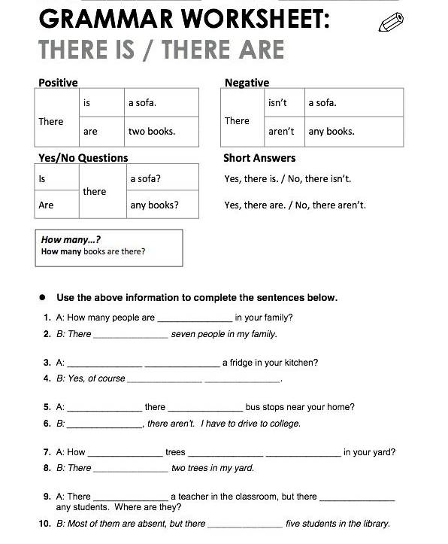

10th, February, 2016
ADOPTION OF ENGLISH GROUP Teacher’s signature

PHẠM THỊ THU HIỀN

Subject: ENGLISH 2  Lesson plan: 3  Date of teaching: 28/03/2016 | Time allowed: 7 periods | Total period taught: 14
UNIT 3: DID YOU HAVE A GOOD TIME?
I. OBJECTIVES: By the end of the lesson, the students will be able to:
-Listen to stories about things that went wrong on vacation .
-Talk about vacations.
-Read an article about a famouse Hotel in Canada.
-Enhance target vocabulary about vacation activities.
-Learn the simple past
-Practise final -ed sounds.
II. METHOD
Integrated, communicative oriented teaching approach.
III. TECHNIQUES
-Pair work.
-Group work.
IV. TEACHING AIDS
Textbook.
Black board, chalk.
Pictures for teaching vocabulary.
Cassette player, amplifier, microphone.
V. PROCEDURE
A. Greetings.
B. Checking students’ attendance: 5 minutes
C. Revision of the old lesson

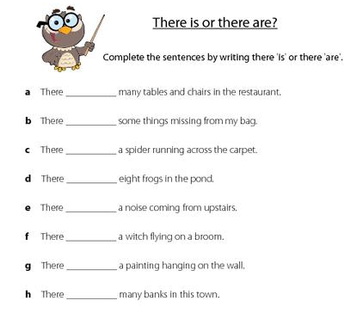

D.New lesson.

Lesson’s contents | Time | Teacher’s activities | Students’ activities
1. Vocabulary: The goal of this section is to talk about vacation.  1.1. Activity 1:  Warm-up  1.2.Activity 2  Match the phrases with the pictures  1.3. Activity 3:  Listen and check  1.4. Activity 4:  Pair work  focus the students’ attention on vocabulary, grammar point, pronunciation and intonation.  2. Conversation: The goal of this section is to talk about places to visit  2.1. Activity 1:  Picture describing  2.2. Activity 2:  Complete the conversation  2.3. Activity 3:  Pair work  2.4. Activity 4:  Free production  3. Language Practice: The goal of this section is to present and practice Simple Past  3.1. Activity 1:  Complete the sentences.  3.2. Activity 2:  Complete the questions  3.3. Activity 3:  Pair work  4. Pronunciation: The goal of this section is to present the final -ed.  4.1. Activity 1:  Listen and repeat.  4.2. Activity 2:  Listen and check  5. Listening: The goal of this section is to present and practice listening selectively for key information.  5.1. Activity 1:  Picture describing  5.2.Activity 2:  Listen and number the pictures  Activity 2:  Complete the chart  6. Smart Talk: The goal of this section is to practice speaking for specific topic: Don’t miss it!  6.1. Activity 1:  Fill-in-the-blank and pair-work activities (Controlled practice)  6.2. Activity 2:  Fill-in-the-blank and pair-work activities(Open practice)  7. Reading: The goal of this section is to practice reading comprehension  7.1. Activity 1:  Picture describing  7.2. Activity 2  Answer the questions  8. Enjoying English: The goal of this section is to practice language in the unit in an enjoyable, meaningful and personalized way.  8.1. Activity 1:  Brainstorm ideas  8.2. Activity 2:  Group work  8.3. Activity 3:  Group work  9. Writing: The goal of this section is to present and practice writing for a specific topic.  9.1. Activity 1:  Writing a paragraph about your best (or worst) vacation  9.2. Activity 2:  Pair work  speak up and exchange information about their emails. | 25’  20’  45’  15’  40’  25’  60’  25’  45’ | - T describes a vacation she/he took.  - T writes some details on the board.  - T elicits similar examples.  - T focuses Ss’ attention on the pictures.  - T models the target vocabulary.    Luggage(n): using picture  Sunburn(n): using example  Climb(v):using mime    Postcard(n)using picture  - T asks Ss to complete the activity on their own  - T plays the CD player.  - T has Ss listen and check their work in Activity 1.  -T models the conversation.  -T reviews the adverbs of frequency and writes them on the board.  -T selects two Ss and has them make a conversation.  - T lets Ss work in pairs practicing speaking.  - T has Ss look at the picture and asks them some questions.  What can you see in the pictures?  Where are they?  What are they talking about?  - T focuses Ss’ attention on the conversation.  - T pre-teaches some words and phrases.  Awesome(adj): using synonym  It’s a secret!: using context.  Anyone interesting: using explanation.  - T has Ss complete the conversation on their own.  - T lets Ss listen to the conversation and check their answers.  - T has Ss work in pairs practicing the conversation.  -T shows the example first.  - T has Ss practice the conversation in pairs again substituting the blanks with the new words given in the box.  - T elicits some places and activities.  - T has Ss practice the conversation in pairs using their own ideas.  - T asks Ss what they did at the last weekend and writes sample sentences in Simple past  - T gives the structure.  -T has Ss give some more examples to check understandings.  -T gives instruction and example.  - T asks Ss to complete the questions in pairs.  - T sets time-limit.  - T conducts the feedback orally.  - T asks Ss to complete the conversations in pairs.  - T sets time-limit.  - T conducts the feedback orally.  -T models the example and gives instructions.  -T has Ss write their own questions.  -T has Ss work in pairs, ask and answer questions they have just written  -T checks the Ss’ work and give feedback  -T models the examples.  - T plays the CD player.  - T asks Ss to say what they notice.  - T has Ss listen and repeat the sentences.  - T asks Ss to listen and check the correct column.  - T focuses Ss’ attention on the pictures and asks them some questions.  Where are they?  What do you know about them?  -T elicits some related vocabulary.  - T plays the CD player and lets Ss listen and number the pictures.  - T checks the answers orally.  -T focuses Ss on the chart.  - T plays the CD player and lets Ss listen and complete the chart.  - T checks the answers orally.  - T assigns roles and gives instructions  - T asks Ss to work in pairs asking and answering the questions to do the gap-filling.  - T asks Ss to work in pairs to exchange information  - T focuses Ss’ attention on the pictures and asks them some questions:  What kind of place is this?  What can you do there?  - T teaches new words if necessary.  Unique (adj): using explanation.  Temperature (n): using example.  Ceiling (n): using mime    Ice sculpture (n): using picture    Skating rink (n):using picture    wedding chapel(n):using picture    Mattress(n):using picture  -T plays the recording.  - T asks Ss to read the text silently and answer the question in pairs.  - T checks Ss’ answers.  - T has Ss think about their best vacations.  -T reviews the items in the survey.  - T elicits possible questions for items 10 on the survey.  - T has students write their own questions and finish the column YOU.  - T models asking and answering the survey questions.  -T has two Ss demonstrate the conversation.  - T lets Ss work in group and complete the survey.  -T writes the example questions on the board.  -T invites Ss to describe their best vacation.  -T elicits other related questions.  - T lets Ss work in group and complete the survey.  - T asks Ss to read the article and answer some comprehension questions.  Where did Jack go?  When did he go?  Where did he visit?  Did he like Guilin?  Did he like San Francisco?  What was his worst vacation?  - T elicits examples or best vacations and worst vacations.  - T asks Ss to write a paragraph about their best vacation.  - T asks Ss to speak up, exchange information and compare paragraphs with their partners. | -Ss listen to T.  -Ss respond to T.  -Ss focus on the pictures.  -Ss take note the new vocabulary.  -Ss do the activity.  -Ss listen and check their answer.  Answer:  1h – 2b – 3a – 4f – 5g – 6c – 7d – 8e– 9j – 10i  -Ss work in pairs and practice saying the conversation.  -Ss focus on the picture and answer the questions.  -Ss read the conversation.  -Ss take note new words and phrases.  -Ss do the activity.  Answer:  1b – 2a – 3c – 4d  -Ss demonstrate the conversation in pairs.  -Ss focus on T.  -Ss do the activity in pairs.  -Ss respond to T.  -Ss make pairs and do the activity.  -Ss respond to T.  -Ss take note.  -Ss give examples.  -Ss do the activity and check their answer.  Answer:  1.met  2.wrote  3.flew, drove  4.went, look  5.made, lost  -Ss complete the task and check the answer.  Answer:  1.Where did you go on your last vacation?  2.How long did you stay there?  3.Where did you stay?  4.Did you do anything interesting?  5.Did you meet anyone interesting?  -Ss focus on T’s instruction.  -Ss do the task.  -Ss do the activity in pairs.  - Ss listen and notice the pronunciation of the final –ed  -Ss repeat the examples.  -Ss do the activity.  Answer:  1/t/ - 2/d/ - 3/Id/ - 4/t/ - 5/d/ - 6/Id/  -Ss look at the pictures and answer questions.  -Ss respond to T.  -Ss listen and do the activity.  -Ss check the answers.  Answer:  Mexico City: 3  Rome: 2  Hong Kong: 1  -Ss listen and do the activity.  -Ss check the answer.  Answer:  1.Hong Kong; No; He got a sunburn  2.Rome; Yes; The airline lost her luggage  3.Mexico City; No; He lost his passport  -Ss follow T’s instruction.  -Ss make pairs and complete the task.  -Ss exchange their work.  -Ss look at the pictures and answer the questions.  -Ss take note the new words.  -Ss do the activity.  -Ss check the answers.  Answer:  1.About 20 minutes west of Quebec City in Canada  2.The difference is 24 degrees Celsius  3.You can go to the art galleries, watch a movie, go skating, and get married  4.Four months  5.More than 50000 people  -Ss respond to T  -Ss do the activity.  -Ss listen to T.  -Ss do the activity.  -Ss complete the survey.  -Ss respond to T.  -Ss divide in group and do the survey.  -Ss read the sample article and answer the questions.  -Ss respond to T.  -Ss write their own paragraph.  -Ss exchange their work in pairs.

VI. SUMMARY OF UNIT 3:
- T reminds Ss about:
+ The simple past.
+ Vocabulary and Grammar Exercise.
VII. HOMEWORK:
- Ss have to do again all the exercises.
- Ss prepare for the new lesson.
VIII. SELF-ASSESSMENT:
- The teaching methods are good because:
+ There are facilities and materials for students to study better.
+ The teacher’s preparation is careful.
10th, February, 2016
ADOPTION OF ENGLISH GROUP Teacher’s signature

PHẠM THỊ THU HIỀN

Subject: ENGLISH 2  Lesson plan: 4  Date of teaching: 11/04/2016 | Time allowed: 7 periods | Total period taught: 21
UNIT 4: I’M GOING TO STUDY LAW.
I. OBJECTIVES: By the end of the lesson, the students will be able to:
-Listen to interviews about people’s jobs and future plans .
-Talk about future plans.
-Read an article about studying abroad.
-Enhance target vocabulary about career and schools.
-Learn the structure Going to +Verb
-Practise pronunciation of Going to
II. METHOD
Integrated, communicative oriented teaching approach.
III. TECHNIQUES
-Pair work.
-Group work.
IV. TEACHING AIDS
Textbook.
Black board, chalk.
Pictures for teaching vocabulary.
Cassette player, amplifier, microphone.
V. PROCEDURE
A. Greetings.
B. Checking students’ attendance: 5 minutes
C. Revision of the old lesson: Past Tense

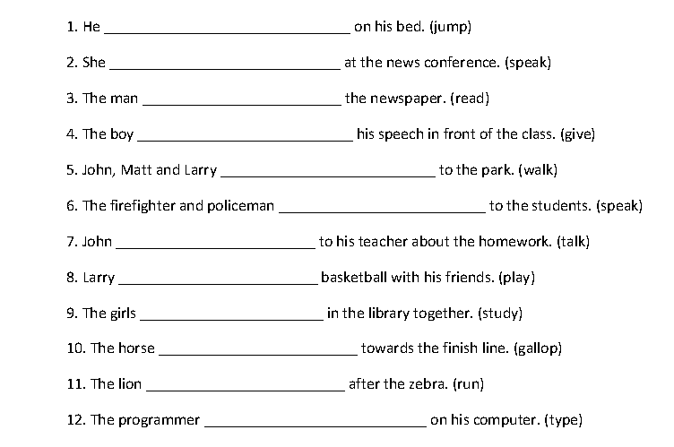

D.New lesson
Lesson’s Contents | Time | Teacher’s activities | Students’ activities
1. Vocabulary: The goal of this section is to present vocabulary about careers and schools  1.1 Warm-up:  1.2. Activity 1:  Match the phrases with the pictures  1.2. Activity 2:  Listen and check  1.3. Activity 3:  Pair work  2. Conversation: The goal of this section is to present and pratice the target vocabulary and grammar of the unit in a typical conversation.  2.1. Activity 1:  Picture describing  2.2. Activity 2:  Listen and check  2.3. Activity 3:  Pair work – Open practice  2.4. Activity 4:  Free production  3. Language Practice: The goal of this section is to present and practice the structure going to + verb  3.1. Activity 1:  Complete the sentences  3.2. Activity 2:  Complete the questions  3.3. Activity 3:  Pair work  4. Pronunciation: The goal of this section is to present the way to reduce “Going to”.  4.1. Activity 1:  Listen and repeat  4.2. Activity 2:  Pair work  5. Listening: The goal of this section is to present and practice listening selectively for key information.  5.1. Activity 1:  Picture describing  5.1. Activity 2:  Listen to the conversation  5.3. Activity 3:  Answer the questions  6. Smart Talk: The goal of this section is to practice speaking for specific topic: She’s going to…  7. Reading: The goal of this section is to practice reading comprehension  7.1. Activity 1:  Reading and answering activities  7.2 Activity 2: Checking True or False  8. Enjoying English: The goal of this section is to practice language in the unit in an enjoyable, meaningful and personalized way.  8.1. Activity 1:  True or false game  8.2. Activity 2:  Group work  8.3. Activity 3:  Class activity  9. Writing: The goal of this section is to present and practice writing for a specific topic.  9.1. Activity 1:  Writing a study abroad plan.  9.2. Activity 2: Group work | 25’  20’  45’  15’  40’  25’  60’  25’  45’ | -T writes the vocabulary items from the book on the board.  -T elicits well-known examples of each kind of school.      -T shows pictures and has Ss guess the careers of people in the pictures.        - T focuses Ss’ attention on the signs.  - T asks Ss if they know any of the schools.  - T models the target vocabulary items- an architecture school, business school, etc.  - T asks Ss to complete the activity on their own.  -T plays the recording and has Ss correct the answers.  -T reviews the structure of can.  - T writes the model conversation on the board and does the sample first.  -T lets Ss work in pair  and sets time limit.  -T invites some pairs to speak up in front of the class.  -T gives feedback.  - T has Ss look at the picture and elicits responses to the questions:  + What jobs does he like?  +Which one is his favorite?  - T pre-teaches the words and phrases.  rich (adj): using antonym  famous (adj): using example  give up (v): using explanation  - T has Ss read the conversation and complete the conversation.  - T plays the CD player and has Ss listen and check the answers.  - T has Ss practice the conversation.  -T corrects pronunciation and intonation.  - T has Ss practice the conversation in pairs again substituting the blanks with the new words given in the box.  -T elicits other careers and schools.  - T has Ss practice the conversation in pairs using their own ideas.  - T introduces the structures.  -T explains to students that going to+ verb is used to express the future plans.  -T lets Ss give examples for checking understanding.  - T focuses Ss’ attention on sentences and the jobs in the box.  - T explains new vocabulary.  Accountant (n):using explanation  - T asks Ss to complete sentecnes  - T sets time-limit.  - T conducts the feedback orally.  - T asks Ss to complete the questions in pairs.  - T conducts the feedback orally.  -T models the conversation and gives the instruction for the class.  - T has Ss work in pairs, asking and practicing their conversations  -T checks the Ss’ work and gives feedback.  -T models the examples and has the Ss repeat.  -T plays the recording and has Ss practice saying the examples.  - T asks Ss to work in pairs practicing asking the questions with their own answers.  - T focuses Ss’attention on the pictures.  -T has Ss describe what they see.  -T pre-teaches new words  hotel clerk(n): using explanation  college (n): using example  save money (n): using explanation  -T gives instruction.  - T plays the CD player.  - T asks Ss to do the task.  - T gives the correct answers.  - T gives instruction, focuses Ss’ attention on 4 kinds of information: name, age, activity, frequency.  -T plays the recording and has Ss do the activity  -T checks the answers  - T reviews useful structure  Are you going to …?  What are you going to…?  -T gives instructions and has Ss do the activity in pairs.  -T gives feedback  -T focuses Ss’ attention on the title and asks Ss some questions:  Are you going to study in another country?  Which country are you going to go to?  -T preteaches new vocabulary.  expensive(adj): using antonym  in common (n): using explanation  electronics company (n): using translation  degree(n): using synonym  major(n): using example  - T asks Ss to read the text silently and answer the questions in pairs.  - T checks the answers.  - T asks Ss to read the text in silence again and work in pairs to complete the information.  - T checks the answers.  -T has Sts read the text and work in pairs to check if the statements are true or false.  - T asks Ss whether they know about Zhang Ziyi and David Beckham or not, and give some information about them.  - T has Ss decide which one is false.  -T gives the feedback.  - T explains the instructions.  -T gives example statements  -T has Ss guess which of the statements is false.  -T has Ss work in group.  -T has Ss talk about their ideal study abroad plans.  -T elicits some information relating to the topic  -T asks students use the aritcle as a model.  -T has Ss write a plan  - T has Ss exchange information about their emails. | -Ss respond to T.  -Ss look at the pictures and guess.  -Ss focus on the signs.  -Ss take note.  -Ss do the activity.  -Ss listen anh check the answers.  Answer:  1.a 3.e 5.g 7.b 9.d  -Ss focus on T.  -Ss work in pairs and do the activity.  -Ss perform for class.  -Ss focus on pictures and respond to T.  -Ss take note.  -Ss complete the conversation.  -Ss listen and check the answers.  -Ss practice saying the conversation.  Answer:  1.A 2.D 3.B 4.C  -Ss make pairs and practice the conversation.  -Ss respond to T.  -Ss do the activity.  -Ss focus on the new structure.  -Ss respond to T.  -Ss focus on T’s instruction.  -Ss take note.  -Ss do the activity.  -Ss check the answers.  Answer:  1.I’m going to be a pilot.  2.She’s going to be a lawyer.  3.He’s going to be a businessman.  4.She’s going to be an actress.  5.They’re going to be directors.  6.They’re going to be doctors.  -Ss do the activity and check the answers.  Answer:  1.Is, going to study  2.Are, going to eat  3.Are, going to go  4.Are, going to watch  5.Is, going to do  6.Are, going to work  -Ss focus on T’s instruction.  -Ss do the activity in pairs.  -Ss listen and practice saying examples.  -Ss do the activity in pairs.  -Ss look at the pictures.  -Ss describe what they see.  -Ss take note.  -Ss listen to T.  -Ss listen the recording and do the activity.  -Ss check the answers.  Answer:  1hates it 2. loves it 3. Likes it  -Ss listen to T.  -Ss do the activity.  -Ss check the answers.  Answer:  1.Julia – 2. Gina – 3.Julia – 4. Don –5. Gina – 6. Don  -Ss listen to T.  -Ss do the activity.  -Ss focus on the title and respond to T.  -Ss take note.  -Ss do the activity and check the answers.  Answer:  Taipei, Taiwan, 22, law  Osaka, Japan, 24, business  Recife, Brazil, 25, computers  -Ss do the activity and check the answers.  Answer:  1T – 2F – 3T – 4T  5F – 6T – 7T – 8T  -Ss do the activity in pairs.  -Ss respond to T.  -Ss do the activity.  -Ss focus on T’s instruction.  -Ss do the activity.  -Ss respond to T.  -Ss read the sample and write their own plans.  -Ss exchange their work.
VI. SUMMARY OF UNIT 4
- T reminds Ss about:
+ Going to
+ Vocabulary and Grammar Exercise.
VII. HOMEWORK:
- Ss have to do again all the exercises.
- Ss prepare for the new lesson.
VIII. SELF-ASSESSMENT:
- The teaching methods are good because:
+ There are facilities and materials for students to study better.
+ The teacher’s preparation is careful.
IV.HANDOUTS

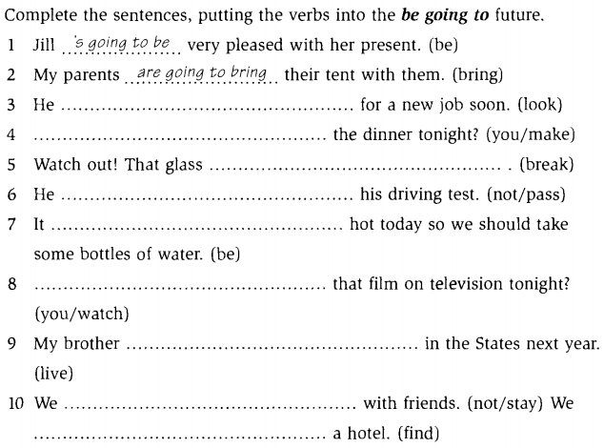

10th, February, 2016
ADOPTION OF ENGLISH GROUP Teacher’s signature

PHẠM THỊ THU HIỀN

Subject: ENGLISH 2  Lesson plan: 5  Date of teaching: 25/04/2016 | Time allowed: 7 periods | Total period taught: 28
REVIEW UNIT 1-4
I. OBJECTIVES: This unit aims to review:
- Vocabulary: Units 1-4
- Grammar: can/ can’t – there is/are – Simple Past – be going to
- Listening: Listening comprension skill
- Reading: Reading comprension skill
II. METHOD
Integrated, communicative oriented teaching approach.
III. TECHNIQUES
-Pair work.
-Group work.
IV. TEACHING AIDS
Textbook.
Black board, chalk.
Pictures for teaching vocabulary.
Cassette player, amplifier, microphone.
V. PROCEDURE
A. Greetings.
B. Checking students’ attendance: 5 minutes
C. Revision of the old lesson: NONE
D. New lesson

Lesson’s contents | Time | Teacher’s activities | Students’ activities
1. Song: the goal of this section is to review the language presented in Unit 1-3.  1.1. Activity 1:  Picture describing  1.2. Activity 2:  Listen and check  2. Listening: Story “Did you have a nice time?  2.1. Activity 1:  Picture describing  2.2. Activity 2:  Complete the conversation  2.3. Activity 3:  Pair-work  2.4. Activity 4:  Free practice  2.5.Activity 5  Workbook | 15’  20’ | -T focuses Ss’ attention on the picture.  -T elicits some vocabulary.  sky (n): using realia  sunrise (n): using explanation  sound (n): using explanation  bark (v) : using example  -T has Ss to fill in the blank.  -T plays the song and has Ss check the answers.  - T focuses Ss’ attention on the comic strip and asks some questions:  Where are the man and woman?  -T pre-teaches some new words.  Fitness center (n): using explanation  nightclub (n): using explanation  - T focuses Ss’ attention on the blanks and the answers choice.  -T models the first example.  -T has Ss do the activity.  -T plays the recording and checks the answers.  -T asks two Ss to model the conversation.  -T check mistakes if any.  -T has Ss practice in pairs.  -T shows the examples and has Ss do the activity.  -T has Ss perform for class  -T has Ss do the workbook. | -Ss focus on picture.  -Ss take note.  -Ss do the activity.  -Ss listen and check the answers.  Answer:  1.woke up 2.got up  3.went out 4.walked  5.saw 6.stood  7.watched 8.rose  9.listened 10drove  11.were 12dreamed  -Ss focus on the comic strip and respond to T.  -Ss take note the vocabulary.  -Ss listen to T.  -Ss do the activity and check the answers.  Answer:  1c– 2b – 3a – 4e – 5d – 6 I slept!  -Ss demonstrate the conversation.  -Ss practice in pairs.  -Ss do the activity.  -Ss perform in front of class.  -Ss do homework.

VI. SUMMARY
- T reminds Ss about main content of the lesson.
VII. HOMEWORK:
- Ss have to do again all the exercises.
- Ss prepare for the new lesson.
VIII. SELF-ASSESSMENT:
- The teaching methods are good because:
+ There are facilities and materials for students to study better.
+ The teacher’s preparation is careful.
10th, February, 2016
ADOPTION OF ENGLISH GROUP Teacher’s signature

PHẠM THỊ THU HIỀN

Subject: ENGLISH 2  Lesson plan: 5  Date of teaching: 25/04/2016 | Time allowed: 7 periods | Total period taught: 30
UNIT 5: HOW WAS YOUR VACATION?
I. OBJECTIVES: By the end of the lesson, the students will be able to:
-Listen to a conversation about people’s last vacations.
-Talk about vacation.
-Write about your likes and dislikes.
-Enhance target vocabulary about places to go and things to do.
-Learn to express agreement and disagreement.
-Practice sentence stress.
II. METHOD
Integrated, communicative oriented teaching approach.
III. TECHNIQUES
-Pair work.
-Group work.
IV. TEACHING AIDS
Textbook.
Black board, chalk.
Pictures for teaching vocabulary.
Cassette player, amplifier, microphone.
V. PROCEDURE
A. Greetings.
B. Checking students’ attendance: 5 minutes
C. Revision of the old lesson: Be Going to+ verb

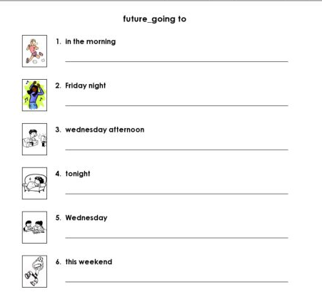

D.New lesson.
Lesson’s contents | Time | Teacher’s activities | Students’ activities
1. Vocabulary: The goal of this section is to supply vocabulary about places to travel and things to do there.  1.1 Activity 1  Filling in the correct list  1.2. Activity 2:  Listen and check  1.3 Activity 3:  Pair work  2. Conversation: The goal of this section is to present and practice the target vocabulary and grammar of the unit in a typical conversation.  2.1. Activity 1:  Picture describing  2.2. Activity 2:  Listen and check  2.3. Activity 3:  Pairwork  2.4 Activity 4:  Free practice  3. Language Practice : The goal of this section is to present and practice Agreeing and Disagreeing  3.1. Activity 1:  Matching the statements and responses  3.2. Activity 2:  Complete the conversation  3.3. Activity 3:  Pair work  4. Pronunciation: The goal of this section is to present and practice the target grammar: Sentence stress  4.1. Activity 1:  Listen and repeat  4.2. Activity 2:  Pair work  5. Listening: The goal of this section is to present and practice listening selectively for key information.  5.1. Activity 1:  Picture describing  5.2. Activity 2:  Listen and complete the chart  5.3. Activity 3:  True or False  6. Smart Talk: The goal of this section is to practice speaking for specific topic:How are you different?  6.1. Activity 1:  Complete the chart (Controlled practice)  6.2. Activity 2:  Pair work (Open practice)  6.3 Activity 3:  Complete the sentences  7. Reading: The goal of this section is to practice reading comprehension.  7.1. Activity 1:  Looking at the map and picture  7.2. Activity 2:  Answer questions  7.3. Activity 3:  Discuss  8. Enjoying English: The goal of this section is to practice language in the unit – the topic: What did you do last summer?  8.1. Activity 1:  Make a list.  8.2. Activity 2:  Group work  8.3: Activity 3:  Class activity  9. Writing: The goal of this section is to present and practice writing for a specific topic “Your likes and dislikes”  9.1. Activity 1:  Write your own email  9.2. Activity 2:  Pair work  speak up and exchange information about their responses. | 35’  35’  40’  20’  25’  30’  40’  30’  35’ | -T presents vocabulary about travelling places and activites through pictures.    The jungle: using picture  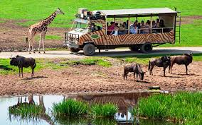  Go on safari: using picture    A tropocal island: using picture  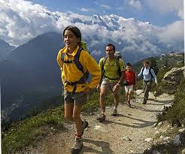  Go hiking: using picture  -T asks Ss to put the words in the box in the correct list.  -T plays the recording to Ss change their incorrect answers.  - T checks their answers.  -T asks Ss about their last vacation.  -T models the conversation for Ss.  -T instructs how to change the underlined vocabulary items.  -T has Ss work in pairs and perform for class.  - T asks Ss to focus on the picture and answer two questions below:  +Where are the people?  +Do they know each other?  -T elicits some responses and writes all them on the board.  - T has Ss read the conversation silently and do the activity on their own.  -T plays the recording and sets time-limit.  -T has Ss change incorrect answers.  -T lets Ss work in pairs practicing the conversation.  -T corretcs pronunciation and intonation.  -T shows Ss the example.  -T has Ss do the activity in pairs.  -T elicits some more words relating to things to do and places to visit.  -T has Ss practice speaking by using their own ideas in pairs.  -T writes the following statements on the board:  +I like going swimming.  +I don’t like going swimming.  -T elicits some responses how to express their agreeing or disagreeing with other’s opinion.  -T reviews all the examples in the chart.  -T asks Ss to give examples for checking understanding.  -T focuses Ss’attention on six sentences.  -T reminds Ss the tenses.  -T has Ss do the activity on their own.  -T corrects the answers.  -T models the sentence one.  -T aks Ss to work in pairs and invites them to go on the board to write down the answers.  -T gives feedback.  -T lets students to do the activity in pairs using their own ideas.  -T invites some pairs to model before class.  -T models the conversation and has Ss practice saying the examples.  -T corrects their mistakes.  - T models the examples and has the Ss repeat.  -T plays the recording and has Ss practice saying the examples.  -T has Ss work in pairs and do the activity.  - T asks Ss to pay attention on the picture, describe what they see and answer the question  “What do you think the people are takling about?”  -T may preteach some new words or phrases.  - T lets Ss listen to the recording.  -T gives the correct answers.  - T plays the recording again to make Ss decide which statements are true or false.  -T gives feedback orally.  -T lets Ss complete the chart with their own information.  -T makes Ss to work in pairs to exchange the information each other.  -T invites some pairs to practice the conversation before class.  -T writes down four sentences on the board.  -T instructs Ss to use below questions to ask their partners:  +What kind of people do you like?  +What do you like to do on vacation?  +What don’t you like to do?  +What are you good at?  -T sets time-limit.  -T gives feedback.  -T asks Ss to focus on the map and picture.  -T has Ss answer the question  “What do you think the Three Peaks Challenge is?”  -T preteches new words.  peak (v): using drawing  challenge (n): using translation  raise money: using example  charity: using explanation  exhausted(adj): using synonym  -T lets Ss read the article silently and underline new vocabulary.  - T asks comprehensive questions.  -T has Ss do the activity.  - T asks some students to write down their answers on the board.  -T gives the correct answers.  -T divides Ss into small groups.  -T elicits responses from each group.  -T writes down again the request “Make a list of eight things you did last summer?”  -T models her eight thing list first.  -T elicits some responses from Ss.  -T makes some time for Ss to fill their list.  -T asks Ss to compare their lists in small group.  -T asks one representative of each group to speak in front of class what each member did last summer.  -T corrects the grammatical, pronunciation mistakes if any.  -T asks Ss to read the sample online conversation and then write responses about their likes and dislikes.  - T goes around the class to help students if they need.  - T asks Ss to speak up, exchange information about their responses with their partners. | -Ss listen and take note.  -Ss do the activity on the own.  -Ss listen and check the answers.  Answer:  Places to go:e, g, h, j, k, n  Things to do:d, e, f, i, l, m  -Ss respond to T.  -Ss listen to T.  -Ss do the activity in pairs.  -Ss look at the picture and answer the questions.  -Ss read and fill in the blank.  -Ss listen and check the answers.  Answer:  1d – 2b – 3c – 4a  -Ss work in pairs practicing the conversation.  -Ss listen to T.  -Ss do the activity.  -Ss respond to T.  -Ss do the activity.  -Ss focus on the board.  -Ss respond to T.  -Ss give their own examples.  -Ss focus on two columns.  -Ss do the activity  -Ss check the answers.  Answer:  1e – 2c – 3a – 4f – 5b – 6d  -Ss listen to T.  -Ss work in pairs and do the activity.  -Ss check the answers.  Answer:  1.So do I  2.Well I did  3.Really I don’t  4.Neither do I  5.Neither can I  6.I’m not  -T has Ss do the activity.  -Ss repeat after T.  -Ss listen and practice saying.  -Ss pratice the conversation using their own information.  -Ss look at the picture and describe it.  -Ss take note.  -Ss listen and complete the chart.  -Ss check the answers.  Answer:  2Joanne – 3Joanne – 4 Tom – 5 Joanne  -Ss listen and do the activity.  -Ss check the answers.  Answer:  1T – 2F – 3F – 4F  -Ss do the activity.  -Ss make pairs and exchange their information.  -Ss perform for class.  -Ss look at the board.  -Ss respond to T.  -Ss do the activiy.  -Ss focus on the picture and answer the question.  -Ss take note new words.  -Ss respond to T.  - Ss do the activity on their own.  -Ss check the answer.  Answer:  1.Andy  2.Crazy  3.Exhausted  4.Happy  5.$1000  -Ss discuss in group.  -Ss listen to T.  -Ss respond to T.  -Ss do the activity.  -Ss discuss in group.  -Ss perform for class.  -Ss read the sample and write their email.  -Ss exchange their work.

VI. SUMMARY OF UNIT 5:
- T reminds Ss about main content of the lesson.
VII. HOMEWORK:
- Ss have to do again all the exercises.
- Ss prepare for the new lesson.
VIII. SELF-ASSESSMENT:
- The teaching methods are good because:
+ There are facilities and materials for students to study better.
+ The teacher’s preparation is careful.

10th, February, 2016
ADOPTION OF ENGLISH GROUP Teacher’s signature

PHẠM THỊ THU HIỀN

Subject: ENGLISH 2  Lesson plan: 6  Date of teaching: 09/05/2016 | Time allowed: 7 periods | Total period taught: 37
UNIT 5: I THINK IT’S EXCITING!
I. OBJECTIVES: By the end of the lesson, the students will be able to:
-Listen to people talking about why they were late.
-Give opinions about movies and music.
-Read an article about people’s opinions about the cost of hit movies.
-Write to a pen pal in another country.
-Extend vocabulary about movies and music.
-Learn adjectives with –ing and –ed.
-Practice syllable stress.
II. METHOD
Integrated, communicative oriented teaching approach.
III. TECHNIQUES
-Pair work.
-Group work.
IV. TEACHING AIDS
Textbook.
Black board, chalk.
Pictures for teaching vocabulary.
Cassette player, amplifier, microphone.
V. PROCEDURE
A. Greetings.
B. Checking students’ attendance: 5 minutes
C. Revision of the old lesson: none
D.New lesson.

Lesson’s contents | Time | Teacher’s activities | Students’ activities
1. Vocabulary: The goal of this section is to talk about movies and music.  1.1. Activity 1:  Putting the words in the box in the correct list.  1.2. Activity 2:  Listen and check  1.3. Activity 3:  Pair work: What kinds of movies and music do you like?  1.4. Activity 4:  Stretch your vocabulary  2. Conversation: 2.1. Activity 1:  Picture describing  2.2. Activity 2:  Listen and check  2.3. Activity 3:  Pair work  2.4. Activity 4:  Free practice.  3. Language Practice: The goal of this section is to present and practice the target grammar: Adjectives with –ng and -ed  3.1. Activity 1:  Complete the sentences.  3.2. Activity 2:  Write your opinions about these things  3.3. Activity 3:  Pair- work.  4. Pronunciation: The goal of this section is to present syllable stress  4.1. Activity 1:  Listen and repeat.  4.2. Activity 2:  Listen and check  5. Listening: The goal of this section is to present and practice listening selectively for key information.  5.1. Activity 1:  Picture describing  5.2 Activity 2:  Complete the chart  5.3 Activity 3: Answer questions  6. Smart Talk: The goal of this section is to practice speaking for specific topic.  6.1. Activity 1:  Pair work  6.2. Activity 2:  Talk bout favorite movies and music  7. Reading: The goal of this section is to present and practice reading for specific information and to discuss the reading passage.  7.1. Activity 1:  Picture describing  7.2. Activity 2  Matching  8. Enjoying English:  8.1. Activity 1:  Complete the survey  8.2. Activity 2:  Group work  9. Writing:  9.1. Activity 1:  Writing an email  9.2. Activity 2:  Pair work | 25’  20’  45’  15’  40’  25’  60’  25’  45’ | - T focuses Ss’ attention on the vocabulary in the box.  - T checks which phrases Ss already know.  - T models the target vocabulary, using pictures of some famous movies and singers                  - T asks Ss to complete the activity on their own.  - T plays the recording.  - T has Ss listen and check their work in Activity 1.  - T gives the correct answers.  -T models the conversation.  -T explains how to change the underlined words.  - T lets Ss work in pairs practicing speaking.  -T corrects the pronunciation mistakes if any.  -T has pairs present the conversation.  - T asks Ss to make a list of movies and music they know.  - T has Ss look at the picture and asks them the question.  Who are the people?  What are they doing?  -T focuses Ss’ attention on the model conversation.  -T pre-teaches the words and phrases  Can’t stand: using context  -T has Ss do the activity  -T plays the recording and checks the answers.  -T asks two Ss to model the conversation.  -T shows the example.  - T has Ss work in pairs and practice the conversation.  -T explains how to change the word “an action movie” to go into the first blank.  - T has Ss practice the conversation in pairs again substituting the blanks with the new words given in the box.  - T has students practice the conversation in pairs using their own ideas.  - T presents the examples.  The action movies are interesting.  I’m interested in action movies.  -T elicits the meaning of examples.  - T introduces the structures.  -T has Ss give the examples for checking understanding.  -T has Ss do the activity and checks the answers.  - T gives instructions and an example  - T asks Ss to write their opinions.  - T conducts the feedback orally.  -T models the example and gives instructions.  -T has Ss work in pairs to complete the sentences.  -T checks the Ss’ work and gives feedback.  -T models the example and gives instructions.  -T has Ss work in pairs to complete the sentences.  -T checks the Ss’ work and gives feedback.  - T asks Ss to add these words in the book to the correct column.  -T plays the recording and has  Ss fill those words to the correct column.  -T conducts feedback orally.  - T focuses Ss’ attention on the pictures and asks them questions:  What are they doing?  Which picture looks fun to you?  -T elicits realating vocabulary.  - T plays the recording and lets Ss listen and complete the chart.  -T checks the answers.  - T checks the answers orally.  - T plays the CD player and lets students listen and write the correct answers  - T checks the answers orally.  - T instructs how to do this activity.  - T asks Ss to work in pairs asking and answering the questions.  -T conducts the feedback.  -T has Ss fill the chart the information about theirselves and their partners’.  - T asks Ss to answer five questions in textbook.  -T lets Ss work and exchange their answers in pairs.  - T focuses Ss’ attention on the pictures and asks them the question:  What do you know about these movies?  - T asks Ss to explain the title of the article.  -T lets Ss guess the topic of the article.  -T elicits relating vocabulary.  script (n): using explanation  acting (n): using explanation  scenery(n): using explanation  battle scene (n): using explanation    starfighter(v): using picture  special effect(v): using example  energy (n):using explanation  - T asks Ss to read the text silently and answer the question in pairs.  - T checks Ss’ answers.  - T has Ss read the survey and answer on their own.  -T models the conversation.  - T lets students work in group and compare their answers.  - T asks Ss to read the letter from an American student.  -T explains some new vocabulary or phrases.  - T asks Ss to write an email to reply realating to the question what people in your country do in their free time.  -T sets time-limit  - T asks Ss to speak up, exchange information and compare their emails with their partners. | -Ss respond to T.  -Ss do the activity.  -Ss listen and check their answers.  Answer:  Kinds of movie:a, c, d, e, h, j  Kinds of music: b, f, g, i, k, l  -Ss listen to T.  -Ss make pairs and do the activity.  -Ss perform for class.  -Ss look at the picture and answer the questions.  -Ss focus on the model conversation.  -Ss take note the new phrase.  -Ss do the activity and check the answers.  Answer:  1a – 2b – 3d – 4c  -Ss listen to T.  -Ss make pairs and do the activity.  -Ss listen to the instruction.  -Ss do the activity in pairs.  -Ss focus on the examples.  -Ss respond to T.  -Ss take note.  -Ss give their own examples.  -Ss do the activity.  Answer:  disappointing – disappointed  amazing – amazed  tired – tiring  disappointed – disappointing  surprised – surprising  boring – bored  -Ss focus on the instructions.  -Ss do the activity.  -Ss listen to T.  -Ss do the activity in pairs.  -Ss check the answers.  -Ss listen to T and repeat.  -Ss do the activity.  -Ss check the answers.  -Ss look at the pictures and answer these questions.  -Ss listen and complete the chart.  Answer:  Karen – Chicago – law student – stay home, watch DVD  Paul – New York – business student – chat, go online  Emi – Taipei – actress – listen to music  -Ss listen to T.  -Ss answer the questions in pairs.  -Ss check the answers.  Answer:  1.exhausted 2.amazing  3.relaxing 4.interesting  5.tiring 6.peaceful, calm  -Ss work in pairs and fill the chart.  -Ss answer the questions and exchange their information in pairs.  -Ss look at the pictures and answer the questions.  -Ss respond to T.  -Ss take note the new words.  -Ss do the activity.  -Ss check the answers.  Answer:  1e – 2d – 3f – 4c – 5a – 6b  -Ss fill in the survey.  -Ss listen to T.  -Ss do the activity.  -Ss read the sample email.  -Ss take note the vocabulary.  -Ss write the email.  -Ss exchange their work in pairs.

VI. SUMMARY OF UNIT 6:
- T reminds Ss about main content of the lesson.
VII. HOMEWORK:
- Ss have to do again all the exercises.
- Ss prepare for the new lesson.
VIII. SELF-ASSESSMENT:
- The teaching methods are good because:
+ There are facilities and materials for students to study better.
+ The teacher’s preparation is careful.

10th, February, 2016
ADOPTION OF ENGLISH GROUP Teacher’s signature

PHẠM THỊ THU HIỀN

Subject: ENGLISH 2  Lesson plan: 8  Date of teaching: 23/5/2016 | Time allowed: 7 periods | Total period taught: 43
UNIT 7: DO IT BEFORE YOU’RE 30.
I. OBJECTIVES: By the end of the lesson, the students will be able to:
-Listen to interviews with world class athletes.
-Talk about experiences.
-Read an article about an extreme sport legend.
-Write a celebrity interview.
-Extend vocabulary about extreme sports and activities.
-Learn Present Perfect.
-Practice Linked sounds.
II. METHOD
Integrated, communicative oriented teaching approach.
III. TECHNIQUES
-Pair work.
-Group work.
IV. TEACHING AIDS
Textbook.
Black board, chalk.
Pictures for teaching vocabulary.
Cassette player, amplifier, microphone.
V. PROCEDURE
A. Greetings.
B. Checking students’ attendance: 5 minutes
C. Revision of the old lesson: ADJ+ed/ ADJ+ing

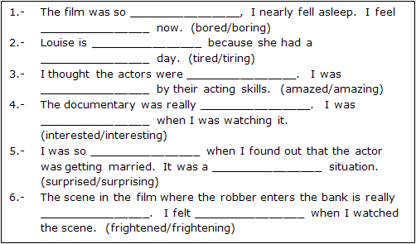

D.New lesson.
Lesson’s Contents | Time | Teacher’s activities | Students’ activities
1. Vocabulary: 1.1. Activity 1:  Matching the pictures and the words in the box  1.2. Activity 2:  2. Conversation: The goal of this section is to talk about sports.  2.1. Activity 1:  Piture describing  2.2. Activity 2:  Listen and check  2.3. Activity 3:  Pair work  2.4. Activity 4:  Free practice  3. Language Practice: The goal of this section is to present and practice the target grammar: Present Perfect  3.12. Activity 1:  Complete the conversations  3.3. Activity 2  Writing sentences about you  3.4.Activity 3:  Pair work  4. Pronunciation: The goal of this section is to present: The linked sounds  4.1. Activity 1:  Listen and repeat  4.2. Activity 2:  Pair work  5. Listening: The goal of this section is to practice listening selctively for key information.  5.1. Activity 1:  Picture describing  5.2. Activity 2:  Listen and number the pictures  5.3. Activity 3:  Listen and complete the chart  6. Smart Talk: The goal of this section is to practice speaking for specific topic: Have you ever seen a celebrity?  6.1. Activity 1:  Fill-in-the-blank and pair-work activities (Controlled practice)  6.2. Activity 2:  Fill-in-the-blank and pair-work activities(Open practice)  7. Reading: The goal of this section is to practice reading comprehension.  7.1. Activity 1:  Picture describing  7.2. Activity 2  Read and answer the questions  8. Enjoying English:  8.1. Activity 1:  Brainstorm ideas  8.2. Activity 2:  Pair work  8.3. Activity 3:  Group work  9. Writing: The goal of this section is to present and practice writing for a specific topic.  9.1. Activity 1:  Writing an interview with a celebrity.  9.2. Activity 2:  Pair work  speak up and exchange information about their interviews. | 25’  20’  45’  15’  40’  25’  60’  25’ | - T focuses Ss’ attention on the pictures.  - T checks which phrases Ss already know.    - T models the target vocabulary, using pictures.  Bungee jumping  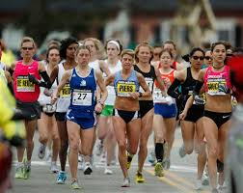  Running a marathon    Parasailing  Kayaking 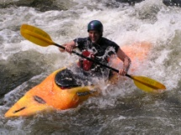  Skiing   Rock climbing 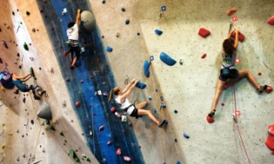    Skydiving    Windsurfing  - T asks Ss to complete the activity on their own.  - T lets Ss work in pairs practicing speaking. (T corrects the pronunciation mistakes if any.)  - T has Ss look at the picture and asks them some questions.  What can you see in the pictures?  Where are they?  What are they talking about?  - T focuses Ss’ attention on the conversation and explains how it relates to the pictures in activity 1.  - T has Ss complete the conversation on their own.  -T plays the recording.  - T lets Ss listen to the conversation and check their answers  - T has Ss work in pairs practicing the conversation.  - T has Ss practice the conversation in pairs again substituting the blanks with the new words given in the box.  - T presents the examples  Have you even gone to Japan?  I have tried bungee jumping.  Huy hasn’t done the rock climbing.  - T introduces the structures and use of Present Perfect.  -T asks Ss to give examples for checking understanding.  -T asks Ss to complete the conversations in pairs.  - T sets time-limit.  - T conducts the feedback orally.  - T gives instructions.  -T lets Ss do the activity.  - T sets time-limit.  - T conducts the feedback orally.  -T models the example and give instructions  -T has Ss work in pairs to ask and answer the questions.  -T checks the Ss’ work and gives feedback  - T plays the CD player.  - T asks students to say what they notice.  - T has Ss listen and repeat the sentences.  - T asks Ss to do the activity in pairs.  - T focuses Ss’ attention on the pictures and asks them some questions.  Where are they?  What do you know about them?  -T elicits relating vocabulary.  hand gliding (n)  triathlon (n)  freestyle skiing (n)  accident (n)  champion (n)  - T plays the CD player and lets Ss listen and number the pictures.  - T checks the answers orally.  -T gives instruction.  - T plays the CD player and lets Ss listen and write the correct letter.  - T checks the answers orally.  - T assigns roles and gives instructions.  - T asks Ss to work in pairs asking and answering the questions to do the gap-filling.  - T asks Ss to work in pairs to exchange information.  - T focuses Ss’ attention on the pictures and asks them to guess the topic.  - T teaches new words.  legend (n): using translation  parachute jump (n): using synonym - skydiving  channel (adj): using example.  altitude(n): using synonym  carbon fin (n): using picture  oxygen tank (n): using picture  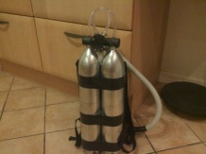    - T asks Ss to read the text silently and answer the question in pairs.  - T checks the answers.  - T elicits possible questions for items 10 on the survey  - T has Ss write their own questions and finish the column.  - T models asking and answering the survey questions.  - T lets Ss work in pairs and complete the survey.  - T lets Ss work in group and complete the survey.  - T asks Ss to read the article and answer some comprehension questions.  - T elicits examples.  - T asks Ss to write an email about their city taking the comprehension questions as clues.  - T asks Ss to speak up, exchange information and compare paragraphs with their partners. | -Ss look at the pictures.  -Ss take note the new words.  -Ss do the activity.  -Ss practice saying the conversation in pairs.  -Ss focus on the pictures and asnwer the questions.  -Ss listen to T.  -Ss fill in the blank on their own.  -Ss listen and check the answers.  Answer:  1c – 2b – 3d – 4a  -Ss do the activity in pairs.  -Ss do the activity.  -Ss listen to T.  -Ss take note.  -Ss respond to T.  -Ss listen to T.  -Ss complete the activity.  -Ss do the activity.  Answer:  1.eaten  2.have – tried  3.gone – have – went  4.met – haven’t  5.run – ran  -Ss do the activity.  -Ss check their answers.  -Ss listen to T.  -Ss do the activity.  - Ss listen and notice the pronunciation of the final -ed.  -Ss repeat after T.  -Ss do the activity in pairs.  -Ss focus on the pictures and answer questions.  -Ss take note new words.  - Ss listen to the T and do the activity.  -Ss check the answers  Answer:  Barbara – hang gliding – no  Victor – freestyle skiing – yes – broken arm/ leg  Lucy – triathlon – yes – broken hand  -Ss listen to T.  -Ss do the activity and check answers.  Answer:  1T – 2F – 3F – 4F – 5T – 6T  -Ss listen to the instructions.  -Ss do the activity in pairs.  -Ss do the acttivity.  -Ss respond to T.  -Ss take note new words.  -Ss listen to the T and do the activity  -Ss check answers.  Answers:  Australia  Malaysia  35km  14 minutes  tied himself to the top of the speeding Porche  -Ss focus on T’s instructions.  -Ss do the activity.  -Ss listen to T and do the activity in pairs.  -Ss do the activity in group.  -Ss read the acticle and answer questions.  -Ss focus on T.  -Ss write an email.  -Ss exchange their work.

VI. SUMMARY OF UNIT 7:
- T reminds Ss about main content of the lesson.
VII. HOMEWORK:
- Ss have to do again all the exercises.
- Ss prepare for the new lesson.
VIII. SELF-ASSESSMENT:
- The teaching methods are good because:
+ There are facilities and materials for students to study better.
+ The teacher’s preparation is careful.

10th, February, 2016
ADOPTION OF ENGLISH GROUP Teacher’s signature

PHẠM THỊ THU HIỀN

Subject: ENGLISH 2  Lesson plan: 9  Date of teaching: 30/5/2016 | Time allowed: 7 periods | Total period taught: 50
REVIEW UNITS 5-7
I. OBJECTIVES
This unit aims to review:
- Vocabulary: Units 5-6
- Grammar: Agreeing/Disagreeing – Adjectives with –ing/-ed – Present Perfect
- Listening: Listening comprension skill
- Reading: Reading comprension skill
II. METHOD
Integrated, communicative oriented teaching approach.
III. TECHNIQUES
Pair work.
Group work.
IV. TEACHING AIDS
Textbook.
Black board, chalk.
Cassette player, amplifier, microphone.
Handouts to reviews old lesson
V. PROCEDURE
A. Greetings.
B. Checking students’ attendance.
C. Revision of the old lesson.
Present Perfect.

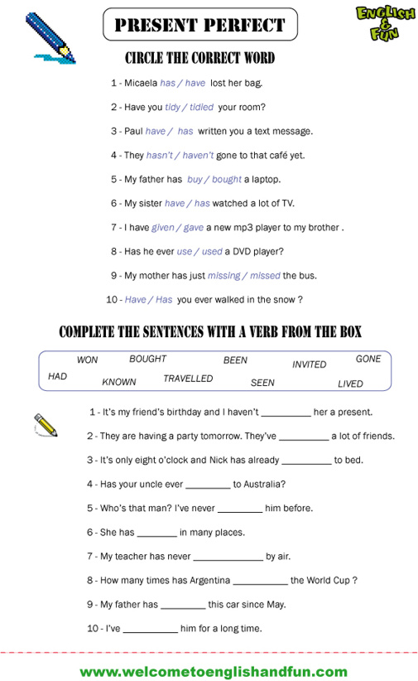

D.New lesson
Lesson’s Contents | Time | Teacher’s Activities | Students’ Activities
1. Song: the goal of this section is to review the language presented in Unit 5-7:  Midnight sun  1.1. Activity 1:  Picture describing  1.2. Activity 2:  Listen and check  2. Listening: Story: Which movie?  2.1. Activity 1:  Answering the question  2.2. Activity 2:  Listen and circle  2.3. Activity 3:  Pair-work practice  2.4. Activity 3:  Pair-work practice  3. Workbook activity | 15’  20’ | - T focuses students’ attention on the pictures.  - T asks Ss some questions:  Where is it?  What are there in the picture?  - T asks Ss to complete the activity on their own.  - T focuses Ss’ attention on the song.  - T plays the recording.  - T checks the answers.  -T focuses Ss’ attention on the comic strip and asks some questions:  Where are people?  What are they doing?  -T focuses Ss’ attention on the blanks and the answers choice.  - T models the first one as an example.  - T has Ss do the activity  -T plays the recording and checks the answers.  -T asks two Ss to model the conversation.  -T has Ss practice in pairs  - T shows the examples and has Ss do the activity.  -T has Ss perform in front of the class. | -Ss look at the pictures.  -Ss answer the questions.  -Ss fill in the blanks.  -Ss listen and check the answers.  Answer:  1.climbed 2.crossed  3. seen 4.seen  5.climbed 6.crossed  7. flown 8. been  9. been  -Ss listen to the T and answer the questions  -Ss respond to the T  -Ss listen to the T  -Ss do the activity  -Ss check the answers  Answers  1c– 2d – 3e – 4a – 5b  -Ss practice the conversation  -Ss do the activity using their ideas.  -Ss perform in front of the class  -Ss do workbook.

VI. SUMMARY: 5 minutes
- T reminds Ss about main content of the lesson
VII. HOMEWORK:
- Ss have to do the workbook and prepare for the new lesson.
VIII. SELF-ASSESSMENT:
- The teaching methods are good because:
+ There are facilities and materials for students to study better.
+ The teacher’s preparation is careful.
10th, February, 2016
ADOPTION OF ENGLISH GROUP Teacher’s signature

PHẠM THỊ THU HIỀN

Subject: ENGLISH  Lesson plan: 10  Date of teaching: 06/06/2016 | Time allowed: 7 periods | Total period taught: 53

UNIT 8: The best place in the world!

I. OBJECTIVES: By the end of the lesson, the students will be able to:
-Describe places
-Read an article about Australia’s most dangerous creatures
-Write about your city
-Extend vocabulary about world geography
-Learn about superlative adjectives
II. METHOD
Integrated, communicative oriented teaching approach.
III. TECHNIQUES
-Pair work.
-Group work.
IV. TEACHING AIDS
Textbook.
Black board, chalk.
Pictures for teaching vocabulary.
Cassette player, amplifier, microphone.
Pictures and hand-outs
V. PROCEDURE
A.Greetings.
B.Checking students’ attendance.
C.Revision of the old lesson.
D. New lesson.
Lesson’s Contents | Time | Teacher’s Activities | Students’ Activities
1. Vocabulary: The goal of this section is to talk about world geography.  1.1. Activity 1:  Picture labelling  1.2. Activity 2:  Listen and check  1.3 Activity 3:  Pair work  2. Conversation: The goal of this section is to talk about world geography.  2.1. Activity 1:  Picture describing  2.2. Activity 2:  Listen and check  2.3. Activity 3:  Pair work  2.4. Activity 4:  Free practice  3. Language Practice: The goal of this section is to present and practice the target grammar: Superlative adjectives.  3.1. Activity 1:  Complete the sentences.  3.2. Activity 2:  Complete the conversations  4. Pronunciation: The goal of this section is to present the World building.  4.1. Activity 1:  Listen and repeat  4.2. Activity 2:  Listen and check  5. Listening: The goal of this section is to present and practice listening for specific information and to do the listening exercises.  5.1. Activity 1:  Picture describing  5.2. Activity 2:  Listen and number the pictures  5.3. Activity 3:  Listen and complete the chart  6. Smart Talk: The goal of this section is to practice speaking for specific topic: The superlative quiz!  6.1. Activity 1:  Fill-in-the-blank and pair-work activities (Controlled practice)  6.2. Activity 2:  Fill-in-the-blank and pair-work activities(Open practice)  7. Reading: The goal of this section is to present and practice reading comprehension.  7.1. Activity 1:  Picture describing.  7.2. Activity 2  Read and answer the questions  7.3. Activity 3  True or False  8. Enjoying English: 8.1. Activity 1:  Brainstorm ideas  8.2. Activity 2:  Pair work  8.3. Activity 3:  Group work  9. Writing: The goal of this section is to present and practice writing for a specific topic.  9.1. Activity 1:  Writing an email describing your city.  9.2. Activity 2:  Pair work | 25’  20’  45’  15’  40’  25’  60’  25’  30’ | - T focuses Ss’ attention on the pictures.  - T checks which phrases Ss already know.  - T models the target vocabulary, using pictures.  - T asks Ss to complete the activity on their own  - T plays the recording.  - T checks the answers.  - T lets Ss work in pairs practicing speaking. (T corrects the pronunciation mistakes if any.)  - T asks Ss to make a list of things they can do.  - T has Ss look at the picture and asks them some questions.  What can you see in the pictures?  Where are they?  What are they talking about?  - T focuses Ss’ attention on the conversation and explains how it relates to the pictures in activity 1.  - T has Ss complete the conversation on their own.  - T lets Ss listen to the conversation and check their answers.  - T has Ss practice the conversation in pairs again substituting the blanks with the new words given in the box.  - T has Ss practice the conversation in pairs using their own ideas.  - T presents the examples.  Huy is the tallest student in the class.  Chi is the most hard- working in the class.  - T introduces the structures and uses of superlative adjectives.  - T asks Ss to give their own examples for checking understanding.  -T models the first sentence.  - T asks Ss to complete the questions in pairs.  - T sets time-limit.  - T conducts the feedback orally.  - T asks Ss to complete the conversations in pairs.  - T sets time-limit.  - T conducts the feedback orally.  - T models the example and let Ss repeat.  - T plays the recording.  - T has Ss listen and repeat the sentences.  - T asks Ss to listen and check the correct column  - T focuses Ss’ attention on the pictures and asks them to describe the place in the pictures.  - T asks Ss some questions.  Where are they?  What do you know about them?  -T elicits relating words.  - T plays the CD player and lets Ss listen and number the pictures.  - T checks the answers orally.  - T plays the CD player and lets Ss listen and write the correct letter.  - T checks the answers orally.  - T assigns roles and gives instructions.  - T asks Ss to work in pairs asking and answering the questions to do the gap-filling.  - T asks Ss to work in pairs to exchange information.  - T focuses Ss’ attention on the pictures and asks them to guess the topic.  - T teaches new words.  poisonous (adj): using explanation  deadly = fatal (adj) using synonym  venom(n) using translation  swallow (v)using mime  protect (v)using example  jelly fish (n)using picture  tentacle (n)using picture  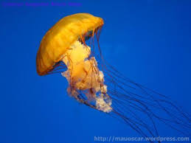  sting (v)using example  electric shock (n)using explanation  -T checks if Ss understand all the questions  -T gives instructions  -T lets Ss listen to the recording.  - T has Ss do the activity.  -T gives intructions.  - T has Ss do in pairs.  -T checks the answers.  - T elicits possible questions for items 10 on the survey  -T gives instructions and has Ss do the activity in pairs  -T gives feedback  -T gives instructions  -T lets Ss work in group, asking and answering questions about their town, country or the world.  -T gives feedback.  -T lets Ss exchange their questions with another group  -T gives feedback  - T asks Ss to read the article and answer some comprehension questions about Denver city.  - T elicits examples.  - T asks Ss to write an email about their  - T asks Ss to speak up, exchange information and compare paragraphs with their partners. | -Ss look at the pictures.  -Ss respond to the T.  -Ss complete the activity.  -Ss listen and check the answers.  Answer:  1e – 2a – 3h – 4c – 5g – 6b – 7d – 8f  -Ss work in pairs practicing speaking.  -Ss respond to T.  -Ss focus on the pictures and answer the questions.  -Ss focus on the model conversation.  -Ss do the activity.  -Ss listen and check the answers.  Answer:  1b- 2a- 3c  -Ss do the activity.  -Ss do the activity in pairs.  -Ss focus on the T.  -Ss take note.  -Ss respond to T.  -Ss do the activity.  -Ss check the answers.  Answer:  1.the deepest  2.the coldest  3.the most common  4.the tallest  5.the most crowded  -Ss do the activity.  -Ss check the answers.  Answer:  1.the widest - the longest  2.the largest - the smallest  3.the driest  4.the richest - the wealthiest  -Ss listen to T and repeat.  -Ss practicing saying examples.  -Ss listen and do the activity.  -Ss describe the pictures.  -Ss answer the questions.  -Ss listen and do the activity.  -Ss check the answers.  Answer:  1b – 2a – 3c – 4b – 5c  -Ss do the activity.  -Ss check the answers.  Answer:  1.3.9 billions  2 .more than 1.3 billions  3. 53  4. Sahara  5. 22 millions  -Ss focus on the T’s instructions.  -Ss do the activity in pairs.  -Ss perform in front of class.  -Ss look at the pictures and guess the topic.  -Ss take note new words.  -Ss read the questions.  -Ss listen the recording and do the activity.  -Ss check the answers.  Answer:  1.Taipei  2.Saltwater crocodile  3.Box jelly  -Ss listen to the T.  - Ss do the acitivity in pairs and check the answers.  Answer:  1F – 2T – 3F – 4F – 5F  -Ss listen to T and do the activity.  -Ss correct the answers.  -Ss listen to the T.  -Ss do the activity in pairs.  -Ss do the activity.  -Ss read the model article and answer the questions.  -Ss write an email on their own.  -Ss show their emails and correct.

VI. SUMMARY OF UNIT 8:
- T reminds Ss about:
+ Vocabulary about world geography
+ Superlative adjectives
VII. HOMEWORK:
- Ss have to do the workbook.
VIII. SELF-ASSESSMENT:
- The teaching methods are good because:
+ There are facilities and materials for students to study better.
+ The teacher’s preparation is careful.
IX. HAND-OUTS:
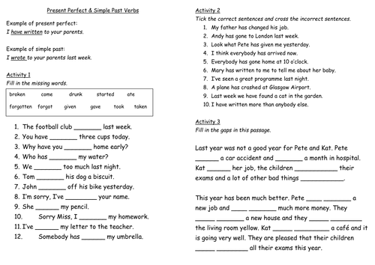

10th, February, 2016
ADOPTION OF ENGLISH GROUP Teacher’s signature

PHẠM THỊ THU HIỀN

